Mauritania

## Freedom House political status

The data set shows the Freedom House political scores and status of the country each year.

## # A tibble: 19 x 5  
## country iso3c date mean status   
## <chr> <chr> <dbl> <dbl> <chr>   
## 1 Mauritania MRT 1996 6 Not Free   
## 2 Mauritania MRT 1998 5.5 Not Free   
## 3 Mauritania MRT 2000 5.5 Not Free   
## 4 Mauritania MRT 2002 5 Partly Free  
## 5 Mauritania MRT 2003 5.5 Not Free   
## 6 Mauritania MRT 2004 5.5 Not Free   
## 7 Mauritania MRT 2005 5 Partly Free  
## 8 Mauritania MRT 2006 4.5 Partly Free  
## 9 Mauritania MRT 2007 4 Partly Free  
## 10 Mauritania MRT 2008 5.5 Not Free   
## 11 Mauritania MRT 2009 5.5 Not Free   
## 12 Mauritania MRT 2010 5.5 Not Free   
## 13 Mauritania MRT 2011 5.5 Not Free   
## 14 Mauritania MRT 2012 5.5 Not Free   
## 15 Mauritania MRT 2013 5.5 Not Free   
## 16 Mauritania MRT 2014 5.5 Not Free   
## 17 Mauritania MRT 2015 5.5 Not Free   
## 18 Mauritania MRT 2016 5.5 Not Free   
## 19 Mauritania MRT 2017 5.5 Not Free

## Freedom House classification of political change

The data set shows the GDP growth and the ecomic growth classification of the country each year.

## # A tibble: 19 x 4  
## country iso3c date politicalChangeFH  
## <chr> <chr> <dbl> <chr>   
## 1 Mauritania MRT 1996 no change   
## 2 Mauritania MRT 1998 democratization   
## 3 Mauritania MRT 2000 no change   
## 4 Mauritania MRT 2002 no change   
## 5 Mauritania MRT 2003 autocratization   
## 6 Mauritania MRT 2004 no change   
## 7 Mauritania MRT 2005 democratization   
## 8 Mauritania MRT 2006 democratization   
## 9 Mauritania MRT 2007 democratization   
## 10 Mauritania MRT 2008 autocratization   
## 11 Mauritania MRT 2009 no change   
## 12 Mauritania MRT 2010 no change   
## 13 Mauritania MRT 2011 no change   
## 14 Mauritania MRT 2012 no change   
## 15 Mauritania MRT 2013 no change   
## 16 Mauritania MRT 2014 no change   
## 17 Mauritania MRT 2015 no change   
## 18 Mauritania MRT 2016 no change   
## 19 Mauritania MRT 2017 no change

## Freedom House score trend

The plot shows the Freedom House scores trend of the country.

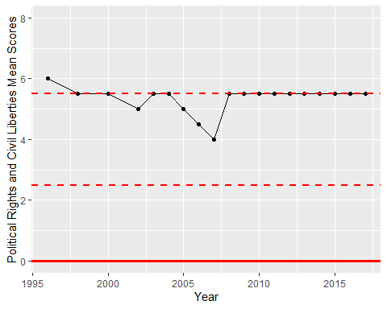

Freedom House Score Trend